# ASR 6120 Request:

1. Expiry SKU master to display timestamps for Add date and edit date.
2. Capture expiry item Putaway update audit trial when user perform location update.

Audit to capture update fields:

Binlocation, Qty Avail, SKU and Expirydate

System update/Changes:

SQL Alter table SCH_Expiry_Item_Putaway_Trans

Add column ToBinlocation, ToQtyavail, ToSKU, ToExpirydate

SQL trigger: ntrSCH_Expiry_Item_Putaway_Update

Insert transaction “UP” into SCH_Expiry_Item_Putaway_Trans

-- AUDIT FOR expiry item putaway:

select * from SCH_Expiry_Item_Putaway_Trans where TranType = 'UP'

1. WMS Expiry Sku item – to display Adddate, addwho , editdate , editwho.
2. Add audit trial for Expiry SKU master – new table: SCH_Expiry_SKU_Audit

Triggers: ntrSCH_Expiry_SKU_Delete , ntrSCH_Expiry_SKU_Update

Test:

Delete SKU STCK333

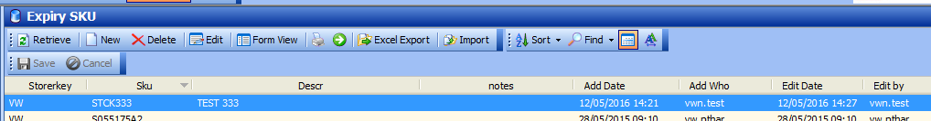

Audit log:



Edit SKU = 02





Updated audit log:

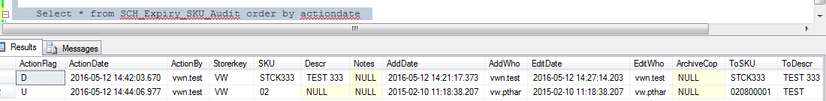

# WMS Change:

## Master:

Expiry SKU



Display fields – Add Date (Creation date), Add By, Edit Date, Edit by.

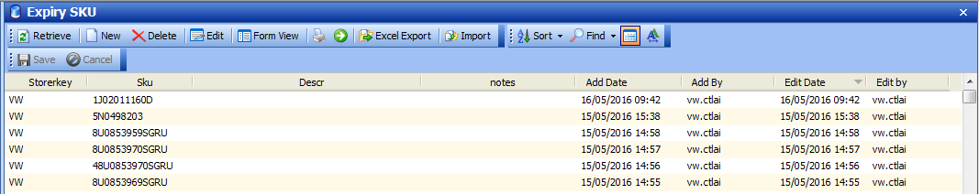

## Report:

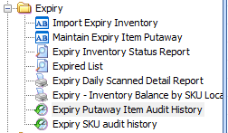

### Expiry Putaway Item Audit History

Report retrieve Expiry SKU master Audit history

Action flag:

U = Update event,

D = Delete event.

Retrieve criteria:

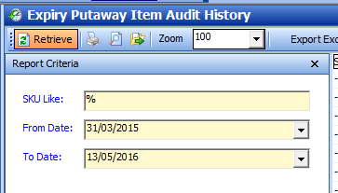

Sample report:

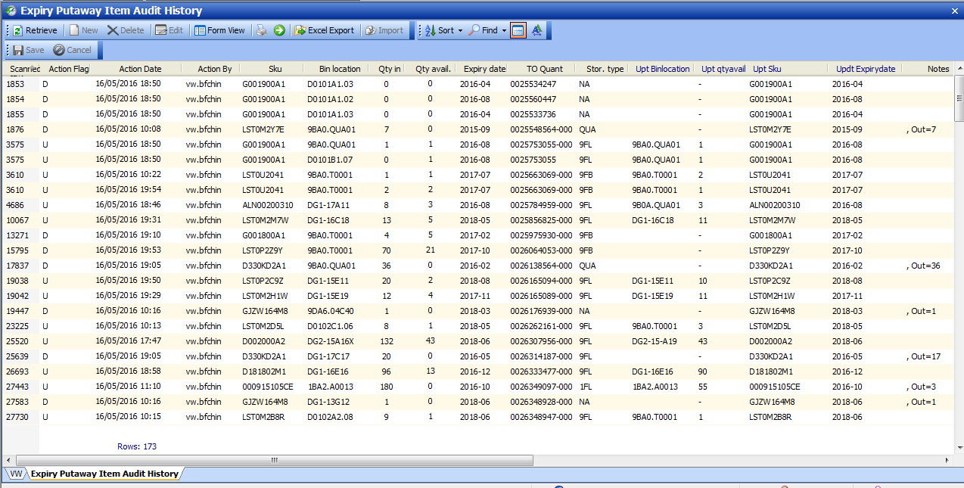

Updated Fields:

* Update Bin Location
* Update QtyAvail
* Update SKU
* Update ExpiryDate

### Expiry SKU (master) Audit history

Description: Report retrieve Expiry Item putaway audit history

Action flag:

U = Update event,

D = Delete event.

N = New

Retrieve criteria:

